Social influence, polarization and AI: Analyzing opinion dynamics and misinformation.
Zofia Broszczak
a)
Within my social network, a specific issue that is polarizing is : “Should vegetarian meals be the default choice in institutional and public settings, such as schools, weddings and flights?". I recently had a conversation with my close ones about whether vegetarian meals should become the default option in institutional and public settings, such as schools, flights and large events, which inspired this choice. I believe this issue is well-suited for this task because it is not too abstract and is highly polarizing and makes it easy for individuals to align with one side or the other.
There are many reasons why people may choose or be encouraged to consume less meat - ranging from ethical and moral reason to environmental considerations and health benefits.
On one side of the debate, some – usually vegetarians and vegans, including myself, argue that making vegetarian meals the default would encourage people to make more environmentally sustainable and ethical choices. Currently, in society, the default meal option typically includes meat. If someone wants a vegetarian meal at a public event, they usually have to request it in advance. They believe that consuming meat should be a conscious decision that requires active selection, rather than a norm. This perspective stems from the idea that reducing meat consumption has well-documented benefits for climate change mitigation, animal welfare and human health (Kwasny, Dobernig, & Riefler, 2022). By making vegetarian meals the standard choice, institutions could influence behaviour in a way that promotes sustainability goals without completely restricting personal choice, as individuals who prefer meat would still have the option to request it.
However, others in my network feel strongly that having vegetarian meals as the default would take away their personal freedom. They also argue that meat consumption is deeply ingrained in many traditions and dietary preferences and that making vegetarian meals the default would unfairly disadvantage those who rely on meat. They usually agree that eating vegetarian is good for ourselves and the planet but believe that the issue is not worth sacrificing their own comfort.
This issue is very controversial because it challenges ideas about food choices, personal freedom and the role of institutions in influencing behaviour. The main debate is whether making vegetarian meals the default is a fair and effective way to encourage change or if it unfairly limits people's freedom to choose what they eat.

Sources:
Kwasny, T., Dobernig, K., & Riefler, P. (2022). Towards reduced meat consumption: A systematic literature review of intervention effectiveness, 2001–2019. Appetite, 168, 105739. https://doi.org/10.1016/j.appet.2021.105739
b1)
Table 1 Table 2
 | x_0
A | 0
B | 0.25
C | 0.75
D | 1
E | 0
 | A | B | C | D | E
A | 0.75 | 0 | 0.5 | 0.75 | 1
B | 0.75 | 0.25 | 0.75 | 1 | 0.75
C | 0.25 | 0.25 | 1 | 0.75 | 0.25
D | 0.5 | 0.25 | 0.75 | 1 | 0.25
E | 0.5 | 0.25 | 0.5 | 0.75 | 0.5

In my micro network, there are three distinct groups of individuals based on their opinions regarding the given statement. The first group consists of vegetarians and vegans, represented by myself (C) and my sister (D), who strongly agree with the statement due to our concerns about the environment and animals’welbeing. We respond with “0.75” and “1” and are moderately influenced by others while being strongly influenced by each other. This is because our shared values and in-depth research on the topic make our conversations particularly productive and eye-opening, whereas other people’s opinions have limited impact on our stance on this topic. The second group comprises individuals who strongly disagree with the statement, responding with “0” (A, E). These are meat-eaters who consume meat daily however, in this case, they are open-minded and are influenced by other people’s opinions. The third group includes an individual (B) who holds mixed opinions, responding with “0.25.” This individual is open to adjusting their views based on the majority’s stance, as they have not given much thought to the subject. Due to their stance not being strong they have only a mild influence on the rest of the network. Most individuals in the network are strongly influenced by others, except for members of the first group (myself and my sister), whose opinions are primarily shaped by each other. The moderate individual in the third group has a weak influence on others due to their lack of a strong stance.
The simulation results reveal that the opinions in the network converge quickly to a consensus value of approximately 0.54 displayed on the graph on the right. The consensus is reached after only five periods, as seen on the middle graph of Graph 1.
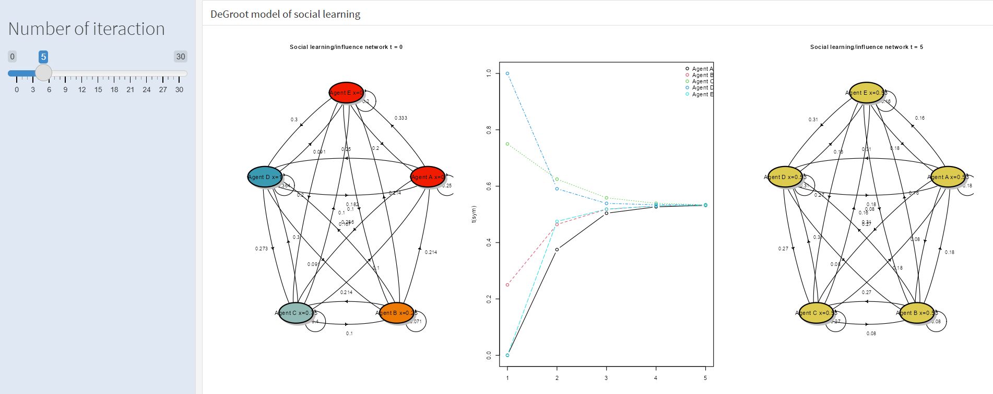
Graph 1 – DeGroot model of social learning

b2)
Table 3 Table 4
 | x_0
A | 0
B | 0.25
C | 0.75
D | 1
E | 0
F - troll | 1/0
 | A | B | C | D | E | F - troll
A | 0.75 | 0 | 0.5 | 0.75 | 1 | 0
B | 0.75 | 0.25 | 0.75 | 1 | 0.75 | 0.25
C | 0.25 | 0.25 | 1 | 0.75 | 0.25 | 0
D | 0.5 | 0.25 | 0.75 | 1 | 0.25 | 0
E | 0.5 | 0.25 | 0.5 | 0.75 | 0.5 | 0.25
F - troll | 0 | 0 | 0 | 0 | 0 | 1
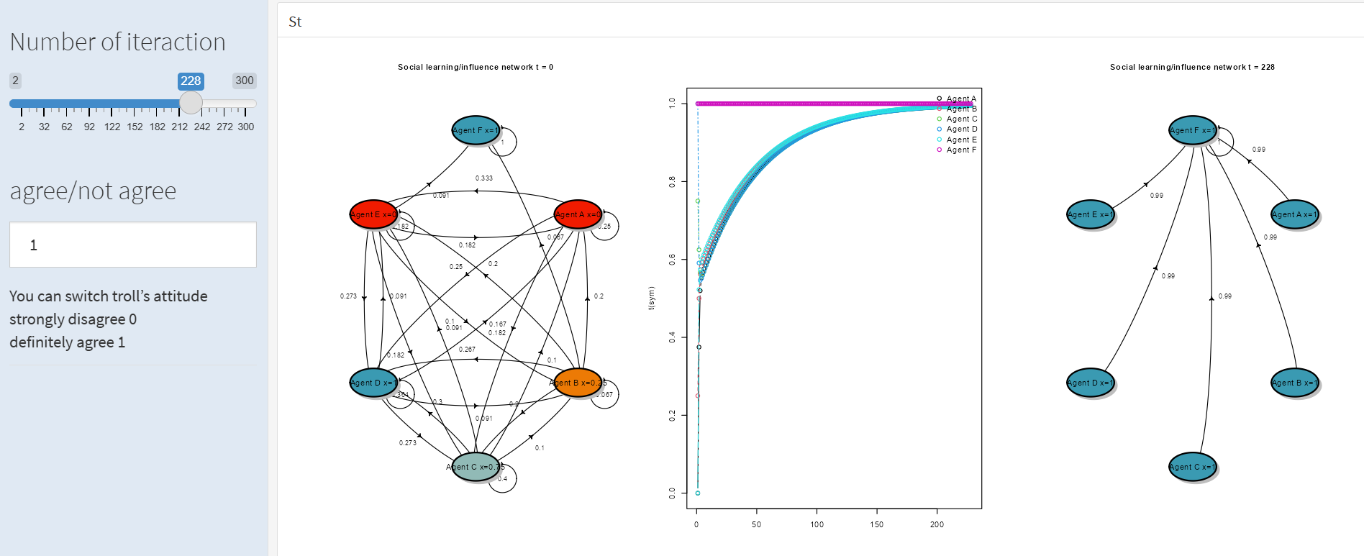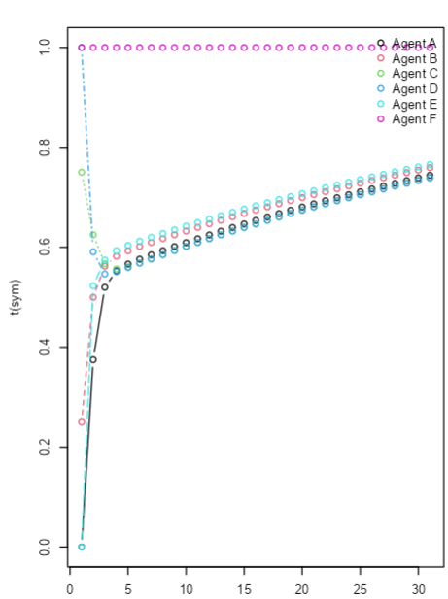
Graph 2 – DeGroot model with the troll answering “1” Graph 2a – middle graph in Graph 2, and influencing two people weakly (0.25). only the first 30 iterations shown

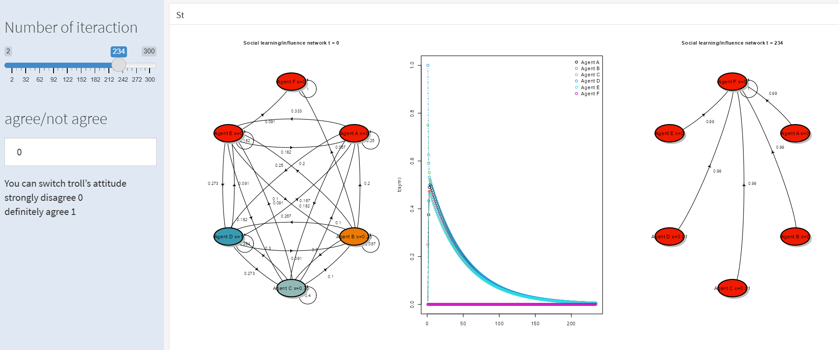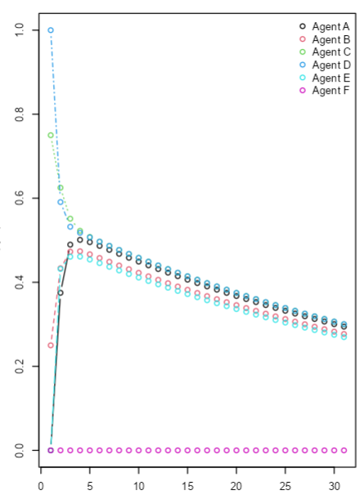
Graph 3 – DeGroot model with the troll answering “0” Graph 3a – middle graph in Graph 3,
and influencing two people weakly (0.25). only the first 30 iterations shown

i)
The simulation results indicate that a troll with an opinion of 1 influences the network slightly faster than a troll with an opinion of 0 (228 versus 234 iterations respectively). Although the mean of the initial responses is closer to 0 than 1 (0.4), a troll with an opinion of 0 affects the network’s behaviour more slowly. This is because individuals with initial responses closer to 1 (Group 1 - Agents C and D) are strongly influenced only by each other and resist influence from others, including the troll. As a result, it takes longer to bring the network to a convergence when the troll’s opinion is 0. When the troll's opinion is 1, the people’s opinions converge towards 1 more quickly as the initial opinion of people most difficult to influence is already close to 1.
ii)
As shown in graphs 2a and 3a, agents directly influenced by the troll (agents B and E) change their opinions to align with the troll’s “opinion” the fastest. This is due to them being directly influenced by the troll, which strongly impacts their opinion updates. On the other hand, agents who are less easily influenced (agents C and D – minimally influenced by others and strongly influenced by each other – creating an ideological bubble) are the least affected by the troll. Even when their initial opinions are closer to the troll’s, they are not directly influenced by it. Instead, their opinions initially decrease due to the influence of others in the network before gradually increasing as the troll's influence reaches them indirectly through other agents (as demonstrated in graph 2a).
iii)
To determine whether it is more effective for the troll to influence one person strongly or many people weakly, three versions of the model were tested. In all versions, the troll’s opinion was set to “1,” as analysing the alternative (troll’s answer set to “0”) would give symmetrical results. In the first version (Graph 4), the troll weakly influenced three agents (B, D and E) with an influence of 0.25 on each. In this case, the network converged to the troll’s opinion after approximately 100 iterations.
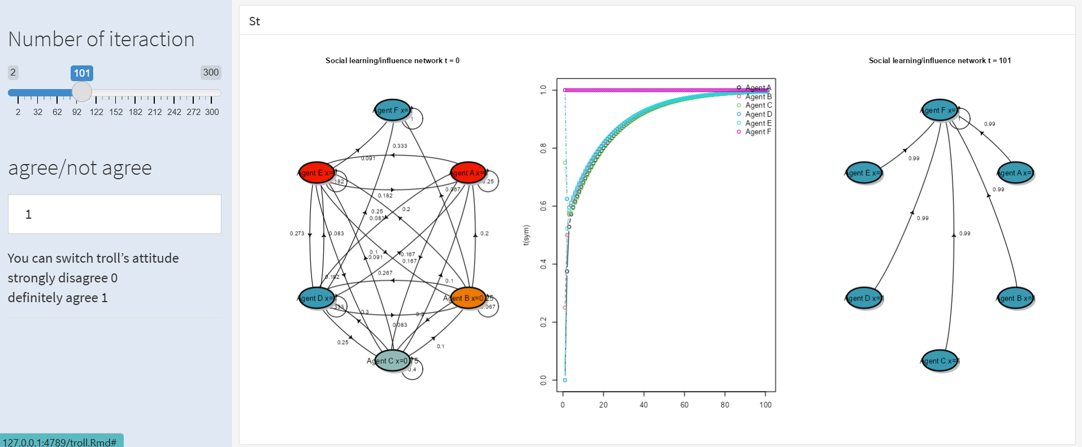
Graph 4 – Model with a troll (set to “1”) with weak influence on three agents (B, D and E)

The second (Graph 5) and third (Graph 6) versions assume that the troll influences one person strongly with an influence of 1. However, a necessary distinction is made between what type of person does the troll choose to influence. In the second version, the troll strongly influenced one agent (B) with an influence of 1. However, agent B had minimal influence on others in the network. As a result, convergence to the troll’s opinion took over 260 iterations, as the strongly influenced agent had little impact on the rest of the network.
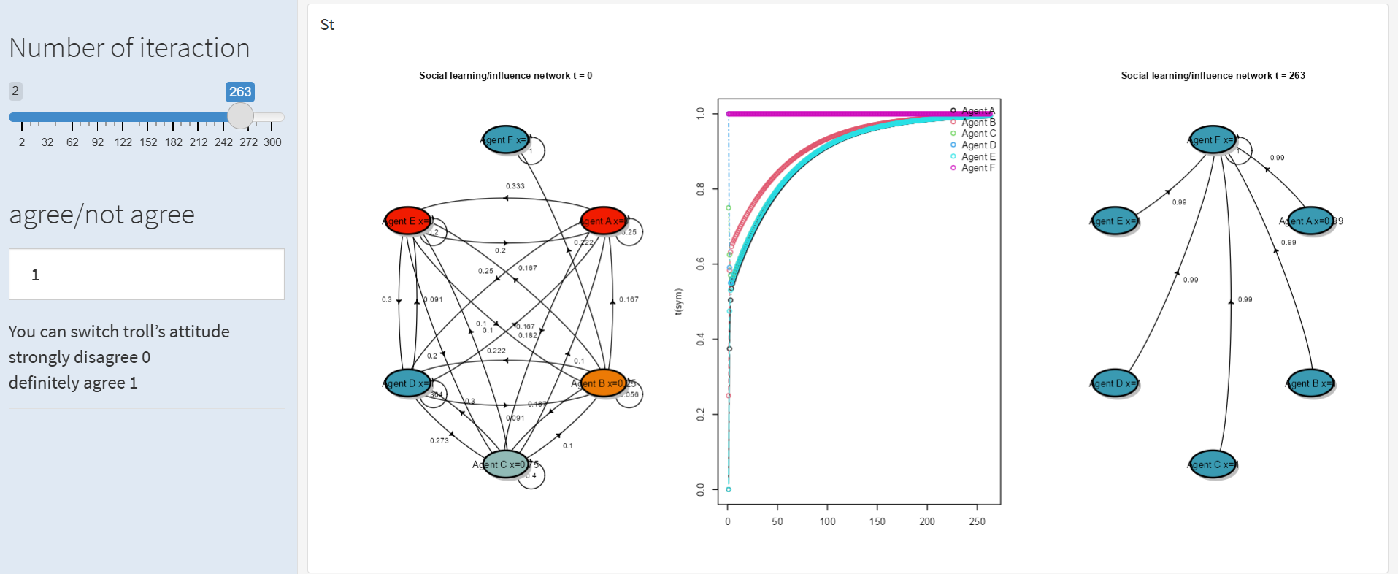
Graph 5 - Model with a troll (set to “1”) with strong influence on one agent who has weak influence on others (agent B)

In the third version, the troll strongly influenced one highly influential agent (D) with an influence of 1. Agent D, having strong influence of 0.75 or 1 on all other agents in the network, caused the network to converge in less than 60 iterations.
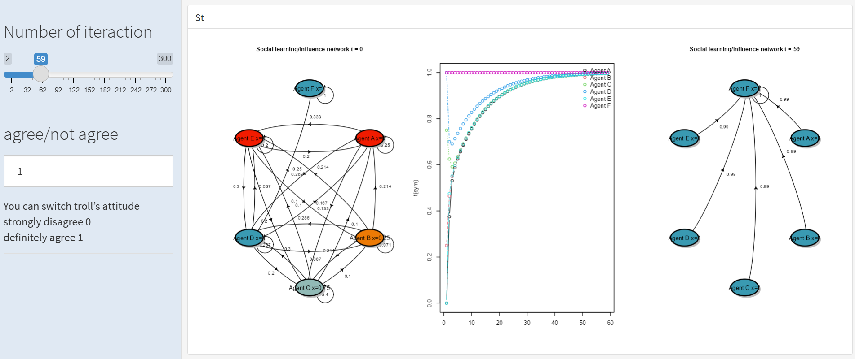
Graph 6 - Model with a troll (set to “1”) with strong influence on one agent who has strong influence on others (agent D)
In conclusion, the most effective strategy for the troll is to strongly influence one highly influential person, such as Agent D. However, realistically, that might not be possible, so the next best option is to weakly influence a few individuals (here three agents with a weight of 0.25 each). The least effective strategy is to strongly influence one person who has minimal influence over others in the network.

c)
Popper’s paradox of tolerance states that "unlimited tolerance must lead to the disappearance of tolerance... We must therefore claim, in the name of tolerance, the right not to tolerate intolerance". [https://www.freiheit.org/mexico/limits-tolerance-poppers-paradox]. The paradox suggests that if we allow intolerant views to spread freely, they can take over and weaken a tolerant society.
The simulation demonstrates Karl Popper’s paradox of tolerance well by illustrating the influence of intolerant trolls on a social network. In this simulation, the troll acts as the intolerant agent by sticking to a fixed belief (either "0" or "1") and gradually influencing others who are open to changing their opinions. The troll can be considered intolerant because both of its fixed opinions (“1” and “0”) are extreme, it wants to influence others without and is not willing to change its own belief. Its ultimate goal is to dominate the network and push everyone toward its set stance. The results of the simulation reveal how the troll gradually drives the entire network toward its extreme belief, regardless of the diversity or initial distribution of opinions. The speed that the troll achieves success depends on its direct influence on certain agents and the structure of the network, especially how easy to influence the agents are.
This experiment proves that not everything should be tolerated online. Two key measures need to be taken. Firstly, given how quickly a single troll can dominate an entire network, there definitely need to be some boundaries set in order to prevent the amplification of harmful, intolerant content. This can be achieved through content moderation, fact-checking mechanisms and restrictions on certain phrases -practices that were once standard across most social media platforms. However, times are changing and now two of the main players in the social media app industry (X and Meta) have reduced content moderation in the name of “free speach” creating an environment where misinformation, discrimination and even incitement to violence flourish. This is why the second measure is just as crucial, if not more so, because it remains within our control. As a society, we must prioritize critical thinking, media literacy and information verification to reduce the influence of trolls and intolerant people. Through experimentation with different data, I discovered that the time it takes for the network to converge can be significantly extended by making present agents (A-E) more difficult to influence and introducing a few agents who are very highly resistant to influence and firm in their opinions. That itself drastically increases the number of iterations needed for convergence in the model with the troll, from 100-200 to over 40,000. This shows how important it is to encourage independent thinking and help people resist manipulation. If individuals are less easily influenced, trolls will have a much harder time spreading their ideas. This can slow down their impact and lead to a more informed and less easily misled online community.
An example of how trolls have fuelled polarization and escalated social and political tensions in Poland is the Russian disinformation campaign. By leveraging trolls to manipulate public perception of the Russian invasion of Ukraine, these campaigns have influenced opinions on a wide range of related issues - from the arrival of Ukrainian refugees in Poland to the potential political consequences of Poland’s support for Ukraine. The reason Russia carries out its disinformation and propaganda campaigns is that the survival of its authoritarian regime is at stake (Legucka & Szczudlik, 2023).
Poland is not the only country targeted by Russian disinformation campaigns – “They create propaganda that even reaches the House of Representatives. This is how Russian troll farms operate.” is a heading of an article regarding Russian trolls impact on the United States (translated to English, from Kazimierczak, 2024). In this report I will focus only on Russian disinformation propaganda directed at Poland.
Russia’s full-scale invasion of Ukraine in 2022, millions of Ukrainians sought refuge in Poland. Initially, the Polish society overwhelmingly supported humanitarian efforts. However, Russian trolls quickly launched an organized disinformation campaign to shift public sentiment against the refugees. The serious danger of troll farms lies in the fact that research shows the Russian government tailors its propaganda to each target audience (Legucka & Szczudlik, 2023).
“The Report on disinformation” by the Commission for investigating Russian and Belarusian influence on Poland's internal security and interests is one of the most reliable sources available on Russian disinformation campaigns targeting Poland as it was written by a commission created by order of the Prime Minister of Poland in 2024. The commission’s job is to aggregate information form government institutions and experts and analyse the extent of Russian and Belarusian interference in different areas of public life in Poland​. The report highlights that Russia has been conducting a strategic, planned and large-scale information war against Poland since at least 2014, when it first invaded Ukraine. However the disinformation campaigns grew stronger after the Russian full invasion of Ukraine in 2022. The report states that the disinformation campaigns target Polish national security, democracy, economy and social stability. The report goes through four main disinformation narratives that are pushed by the Russian government but I will only focus on the narrative justifying Russia’s war in Ukraine. The purpose of the disinformation campaign on this front is to discourage polish support for Ukraine in the war and worsen the relationship between the Polish and the Ukrainians.
These false narratives spread by Russian trolls include several claims on different levels. The report gives the main idea – the narratives mentioned contained claims that Ukraine is controlled by fascists while presenting Russia as the protector and saviour of Eastern Europe. False claims were circulated stating that Polish aid to Ukraine was unnecessary or harmful to the Polish economy​ or political situation. Some examples of these false claims include saying that Ukrainians were a threat to public safety, that the war in Ukraine was fake or that Ukrainian refugees were getting special treatment over Polish citizens, such as having lower fuel prices. At the same time, Russian propaganda spread false narratives about its military successes. Most of this disinformation was pro-Russian, trying to make Poles support Putin while also causing resentment toward Ukrainians. This led to more distrust, xenophobia and division in society. (Makarewicz, 2022). Russian trolls also spread misinformation about Poland’s military support for Ukraine, suggesting that helping Ukraine was a reckless decision that could drag Poland into war (Polish Press Agency (PAP), 2024).
The narratives spread online were later amplified by certain politicians, who used anti-Ukrainian rhetoric potentially to appeal to nationalist voters (Kraushar, 2022). It is difficult to definitely blame these actions completely on disinformation spread by trolls, I am starting to wonder that maybe these politicians should be treated in our model as trolls themselves. However, it is safe to say, that these politicians’ public statements just further strengthened anti-Ukrainian rhetoric promoted by the trolls.
“The Report on disinformation” highlights the other key measure as well, the one that I mentioned above when talking about trolls online. It is the fact that Poland is unprepared in addressing Russian disinformation. The government institutions react to slowly and do not fight the misinformation well enough. The government only established a department to counter scientific disinformation in 2022, despite there being threats for many years. The recommendations of the commission are stronger media literacy programs, the government combating disinformation in real time, improving cybersecurity, introducing laws that require transparency in media funding as well as cooperating with NATO and EU on this matter.
In conclusion, the actions of trolls in Poland have demonstrated how online disinformation can intensify social, economic and political conflicts. By manipulating public sentiment, trolls not only widened divisions within Polish society but also attempted to weaken Poland’s role in supporting Ukraine. This case highlights the dangers of unchecked disinformation and the urgent need for media literacy programs and stronger regulatory measures to mitigate the impact of troll-driven disinformation.

Sources:
Komisja do spraw badania wpływów rosyjskich i białoruskich na bezpieczeństwo wewnętrzne i interesy Rzeczypospolitej Polskiej w latach 2004–2024 (2025). Raport Zespołu ds. Dezinformacji. Ministerstwo Sprawiedliwości. Retrieved February 4, 2025, from https://www.gov.pl/web/sprawiedliwosc/raport-zespolu-ds-dezinformacji-komisji-ds-badania-wplywow-rosyjskich-i-bialoruskich
Kraushar, K. (2022). "Prorosyjska Konfederacja" w "Wiadomościach". TVP wytyka wypowiedzi Korwin-Mikkego. Gazeta.pl. Retrieved February 4, 2025, from https://wiadomosci.gazeta.pl/wiadomosci/7,114883,28510484,prorosyjska-konfederacja-w-wiadomosciach-tvp-wytyka-wypowiedzi.html
Kazimierczak, S. (2024). Tworzą propagandę, która dociera nawet do Izby Reprezentantów. Tak działają rosyjskie farmy trolli. Fakty. Retrieved February 4, 2025, from https://fakty.tvn24.pl/fakty-o-swiecie/od-problemu-z-dostepnoscia-mleka-modyfikowanego-po-zabieranie-pracy-amerykanom-przez-imigrantow-w-jakie-tony-uderzaja-r-st7861582
Makarewicz, B. (2022). Wojna Putina w social mediach. Tak prorosyjska dezinformacja zalewa Polskę. Wiadomości Radio Zet. Retrieved February 4, 2025, from https://wiadomosci.radiozet.pl/polska/Wojna-w-Ukrainie.-Prorosyjska-dezinformacja-w-social-mediach.-Jak-dziala-dowody-analiza
Legucka, A., & Szczudlik, J. (2023). Dezinformacja i propaganda Rosji oraz Chin w kontekście wojny na Ukrainie. Polski Instytut Spraw Międzynarodowych (PISM). Retrieved February 4, 2025, from https://www.pism.pl/publikacje/dezinformacja-i-propaganda-rosji-oraz-chin-w-kontekscie-wojny-na-ukrainie
masz / Polish Press Agency (PAP). (2024). Rosja prowadzi kampanię dezinformacji skupioną na podważeniu poparcia dla pomocy Ukrainie. WirtualneMedia.pl. Retrieved February 4, 2025, from
https://www.wirtualnemedia.pl/artykul/rosja-kampania-dezinformacja-podwazenie-poparcia-dla-pomocy-ukrainie

c1)
AI-based content moderation allows for efficient moderation of massive amounts of content and is essential in fighting misinformation, hate speech and propaganda. However, relevant to Popper’s paradox, some believe that AI content moderation infringes on the right to freedom of expression while others argue that unlimited tolerance of all kinds of content would cause much more harm than good and eventually lead to a destruction of a tolerant society. It is crucial to find a balance between the two.
AI plays a crucial role in content moderation as human moderators are not able to moderate huge amounts of content that are produced all the time. AI-based content moderation works well on paper but in reality it raises concerns about freedom of expression, biased algorithms and the power the companies have on public opinions and on access to information.
For one of my Bachelor’s courses, we studied The Role of Artificial Intelligence in Disinformation by Bontridder & Poullet. I believe that this paper highlights the strengths and weaknesses of AI-based content moderation as well as addresses the root cause of the disinformation problem amazingly well. The authors stress that rather than solely relying on AI to moderate content, the root cause of the disinformation problem must be addressed – social media platforms follow a model that prioritizes engagement over factual accuracy. Unless that changes, the issue of disinformation will persist. The article also states that AI models responsible for content moderation have many weaknesses. They struggle to differentiate between misinformation and disinformation – both are dangerous but while misinformation is unintentional, disinformation is intentional. The authors agree that AI algorithms censor debates which puts freedom of expression at risk. They also describe how AI algorithms rely on biased datasets. Always at the root of data there are humans who by nature are biased. If an AI algorithm learns from biased datasets, the way it operates will be biased as well. Many platforms and apps are not transparent on how AI content moderation works on their product so we have no way to verify if the algorithms are unbiased. The last weakness of AI algorithms for content moderation worth mentioning is that while AI detection is very effective on content in English, it is way less effective on content in other languages simply due to the fact that most of the data that AI algorithms are trained on is in English (Bontridder & Poullet, 2021).
Today, this issue is more relevant than ever, with social media apps loosening its content moderation rules. Elon Musk, a vocal critic of content moderation, significantly reduced AI and human moderation efforts on X (formerly Twitter). Trolls, hate speech, misinformation and extremist content have since flourished demonstrating Popper’s paradox of tolerance in action - by allowing intolerant content without moderation, the platform has become overrun with harmful content. A disturbing example is the spread of revenge porn and leaked personal photos, which remain available for millions to see due to the lack of active moderation. Even those who do not use X regularly visit the platform during scandals. I think it is safe to say, that Musk’s approach to content moderation brings out the worst in everyone. I believe that my stance on reducing content moderation to that extent is clear and I thought that this was a universal opinion. Unfortunately it must not be, as “Meta, YouTube and others loosened restrictions on fact-checking and political misinformation in the lead-up to the 2024 presidential election. The incoming Trump administration in the US has caused major tech and social media companies to adjust their policies in response to the president-elect and Republican legislators, who have long criticized social platforms for perceived censorship of conservative speech.” [https://www.emarketer.com/content/meta-will-ease-up-on-content-moderation-significant-reversal]. These changes highlight the risks of applying the absolute tolerance principle, as intolerant or false and harmful narratives can now spread freely on these apps. It will take time to see how these changes affect Europeans as for apps to be available in Europe their policies (including content moderation) must align with EU regulations. The EU requires transparency and external audits for large online platforms.
The issue described above is a severe example of the consequences of loosening AI content moderation. However, even when AI-based content moderation is in place, significant challenges still persist. In the article Artificial Intelligence Struggles to Moderate COVID Misinformation, Siriwardana highlights the shortcomings of AI when it comes to content moderation is the misinformation and disinformation crisis during the COVID-19 pandemic. A key issue is that most AI content moderation systems rely on supervised learning, which requires large, diverse and well-labelled datasets. However, because the pandemic and the misinformation related to it spread suddenly and rapidly, there was (and still is) insufficient data to train effective supervised learning models. Unsupervised learning techniques, which do not require labelled data, are less commonly used which is problematic in crisis situations. Other major challenges are potential bias of the datasets, lack of transparency in AI decision making and non-user-friendly implementation.
Despite the challenges, researchers argue that AI is essential for content moderation. However, to align AI-based moderation with Popper’s principles, several things need to be ensured. Platforms should use AI to flag, but not automatically remove content, allowing for human review that takes context into account. Instead of focusing solely on removing harmful content, platforms should also promote access to credible sources. Companies should increase transparency on how AI moderation decisions are made. We also need to prevent AI from reinforcing disinformation through engagement-driven algorithms (Bontridder & Poullet, 2021)​. AI algorithms need to be trained on non-biased high-quality datasets and need to be designed by choosing the right features as well as using multi-modal approaches by combining text, image and USL-based features. The models need to be validated across different datasets (Siriwardana, n.d.). However, to solve the root cause of the misinformation crisis, we must address the capitalist-driven social media model, which prioritizes profit and engagement over factual accuracy.

Sources:
Siriwardana, M. (n.d.). Artificial intelligence struggles to moderate COVID misinformation. CoVisualize - Harvard University. Retrieved February 5, 2025, from https://scholar.harvard.edu/cvt/artificial-intelligence-struggles-moderate-covid-misinformation
Bontridder, N., & Poullet, Y. (2021). The role of artificial intelligence in disinformation. Data & Policy, 3, e32. doi:10.1017/dap.2021.20. . Retrieved February 5, 2025, from https://www.cambridge.org/core/journals/data-and-policy/article/role-of-artificial-intelligence-in-disinformation/7C4BF6CA35184F149143DE968FC4C3B6

c2)
Philosophical frameworks such as Karl Popper’s critique of totalitarianism and Hannah Arendt’s reflections on freedom and authoritarian tendencies provide crucial insights for the design of AI moderation policies that balance free expression with the need to curb harmful content. Popper’s principle is particularly relevant when considering how AI content moderation systems should handle extremist rhetoric, misinformation and hate speech without imposing censorship. My reflections in previous sections go into detail on why AI moderations of misinformation and extremist content are necessary and what improvements are necessary. Arendt’s framework on freedom and authoritarism allows us to look at AI content moderation from a different lens. Authoritarian regimes control narratives by limiting free speech and public debate. If AI is too strict in moderation or is trained on biased datasets, it can become a powerful tool of control of the public where only opinions aligning with a totalitarian regime’s ideologies can be shared and sharing any other point of view can put a person in danger.
In "The Politics of AI: Democracy and Authoritarianism in Developing Countries" Fernando Filgueiras explores how AI is embedded in political dynamics and institutional structures. AI policies in authoritarian countries are closely aligned with the interests of the ruling. Countries like China, Russia and Saudi Arabia have used AI to strengthen government control, enhance surveillance and increase geopolitical power. In contrast, democratic countries do not use AI for such aims as they believe that it infringes human rights and freedom of expression. In those countries, AI development is influenced by ethical and regulatory frameworks that prioritize transparency, accountability and human rights.
In the wake of global protests against censorship and the rise of generative AI tools that can spread propaganda or misinformation, it is imperative to design AI moderation systems that do not suppress legitimate viewpoints. Just a few examples of global protests are “PauseAI” protests in cities like London, New York and San Francisco, demanding a temporary pause to advanced AI development over fears that tools like ChatGPT could spread misinformation and suppress legitimate discussion [https://time.com/6977680/ai-protests-international].
To counter the risks described above AI usage and development should be regulated on federal and international level. An example of that is EU’s regulations on AI that aim to ensure that AI systems are safe, transparent and respect fundamental rights. Another way this can be done is for companies to incorporate diverse voices – AI developers, journalists, the society including marginalized communities - into AI policy discussions. Another good way to achieve the balance we want is through explainable AI (XAI). “Explainable artificial intelligence (XAI) is a set of processes and methods that allows human users to comprehend and trust the results and output created by machine learning algorithms.” [https://www.ibm.com/think/topics/explainable-ai]. XAI would ensure that content moderation decisions are transparent and accountable. AI models should be designed with clear rationales for decisions, allowing users to contest or appeal content removals. This aligns with Popper’s advocacy for an open society, where institutions must be accountable and subjected to critical scrutiny. To make sure that AI does not restrict the freedom of expression AI should only flag content it deems as harmful without deleting it. Content flagged as potential misinformation or causing harm would be marked as such so users would approach it more critically. Ideally, at the end there would be human moderators that review posts flagged by AI. Alongside this solution, platforms can allow for collaborative fact-checking by users - a practical application of this idea can be seen in X’s Community Notes. Another crucial point highlighted in previous sections of this report is that AI algorithms should be transparent. A way to expand that beyond laws requiring transparency is by incorporating open-source AI auditing, where independent researchers analyse how content decisions are made. This would counteract the use of AI for centralized control, as observed in totalitarian regimes that manipulate AI for censorship and surveillance. One issue here is that algorithms can be biased because of biased data that they are trained on and it seems impossible to make that data public as companies cannot share people’s personal data.
Ultimately, designing AI systems with these philosophical insights aims at protecting users while maintaining the integrity of free expression. By embedding Popper’s open society principles and Arendt’s warnings against totalitarianism, AI is more likely to resist authoritarian tendencies while promoting democratic discourse at least in democratic countries.
Sources:
Filgueiras, F. (2022). The politics of AI: democracy and authoritarianism in developing countries. Journal of Information Technology & Politics, 19(4), 449–464. https://doi.org/10.1080/19331681.2021.2016543
Gordon, A. (2024). Why Protesters Around the World Are Demanding a Pause on AI Development. Time. Retrieved February 5, 2025, from https://time.com/6977680/ai-protests-international/
IBM. (n.d.). Explainable AI. IBM. Retrieved February 5, 2025, from https://www.ibm.com/think/topics/explainable-ai

d)
I think that the article “Troll on the net - testing the vulnerability of different networks structures on misinformation” by Kopczewski and Kocerka is well structured and quite innovative. It makes a strong theoretical contribution by extending the DeGroot model to include "algorithmic trolls" and demonstrates how a single persistent agent can manipulate entire networks. It was interesting reading this article as a person who is interested in the topic of misinformation and propaganda but has not researched theoretical frameworks and models on this topic. The article has inspired me to analyse this issue through a more scientific lens. Due to my personal interests, I especially enjoyed the parts about MDS and Random Forest in the paper. The explanation of the model and the structure of the paper are quite a good introduction to the topic and allow good understanding and replications.
My overall opinion on the paper is very positive and I have a few reflections on the framework’s potential weaknesses as well as ideas on possible extensions of the model.
One of the issues I have with the DeGroot model is that I believe that in real life quite a lot of people strongly resist changing their opinions regardless of others’ opinions. People tend to avoid changing their opinions as it might cause a clash with their worldview or confront them with the fact that they were wrong. They can be described as stubborn agents and often reject opposing views and seek information elsewhere that reinforces their pre-existing views. Additionally, in real life our networks are often ideological bubbles where an extreme opposing view is met with scrutiny, not conformism. While the model predicts that over time, beliefs within a connected network will converge to a consensus, in real life radicalization and polarization of opinions is very common.
I would like to see the model being validated by real life data by for example analysing specific cases of group chats or online forums where a small network of people was influence by a troll. Additionally, I would love to see the model incorporate varying degrees of troll influence, particularly comparing scenarios where the troll promotes extreme opinions versus moderate opinions at the beginning gradually changing into more extreme ones. In real life, people are generally more influenced by non-extreme misinformation, so it would be interesting to explore how "dynamic" trolls could gradually radicalize agents by progressively shifting their opinions toward more extreme ones. Another potential extension builds on reflections from previous points of this report - I would like to see the model extended to include an “agent” who is a (human or AI) content moderator. This would require accounting for how likely each agent is to change their beliefs when confronted with misinformation warnings or fact-checking interventions. Integrating these misinformation moderation tactics into the model could provide valuable insights into the effectiveness of intervention strategies.

To improve readability of the graph

